





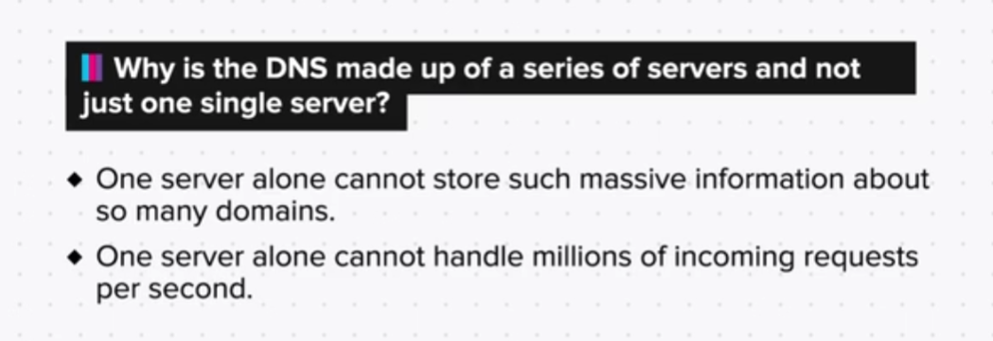

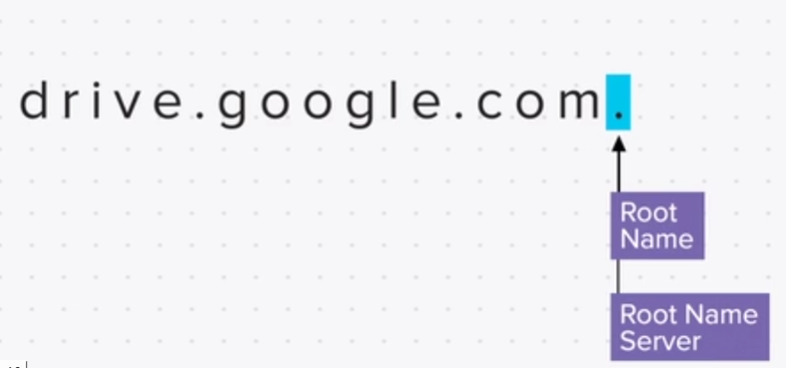



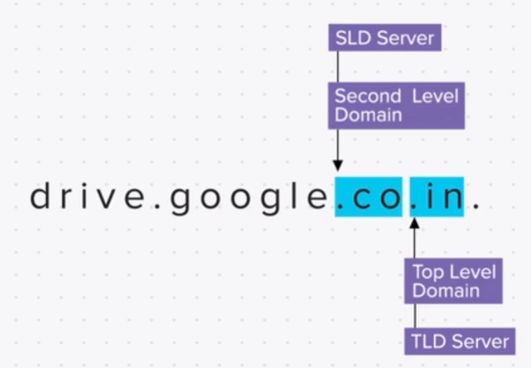



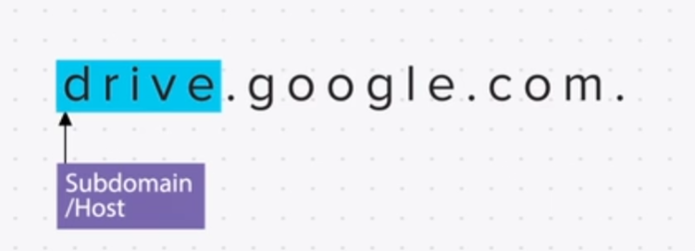

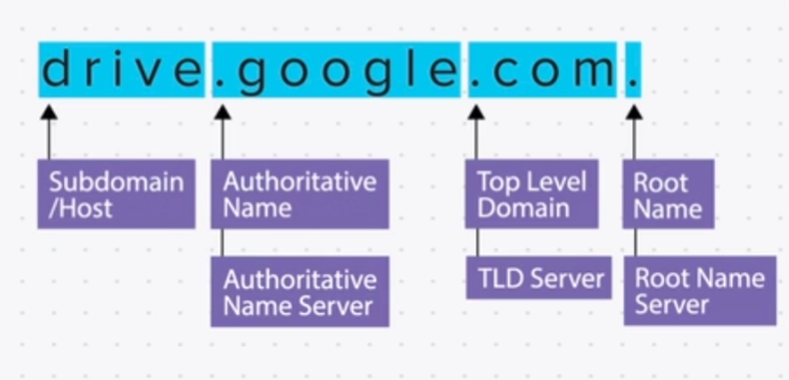

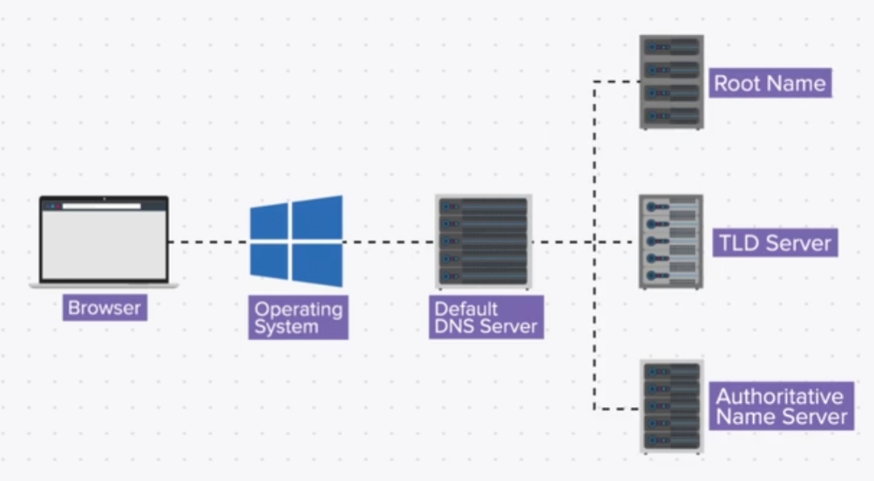

DNS Lookup

So, here are some commands that we can use to do a live DNS lookup and to check for IP addresses of domain names.

For Windows users:

* + Press windows+r to open the Run dialog box.
  + Type cmd and press enter.
  + Type nslookup, space, the domain name that you want to see the IP address for, example: google.com, and press enter.

This will give you the most recent IP addresses of Google.

Summary

Now that we have come to the end of this topic, you should be able to:

1. Explain the purpose of DNS

2. Explain and identify the parts of a domain name

3. Explain the working of DNS, its hierarchy, structure and DNS resolution